**Exploring the Various Ways to Represent Numbers**

When working with numbers, it's important to understand that numbers can be represented in many different ways. Some representations have historical significance while others have emerged for specific use cases. In this article, you'll learn about several common representations of numbers.

**Numerals**

The standard form of numbers is the most common and straightforward way of writing and reading numbers. It is the method we use every day when dealing with numbers in various aspects of our lives, such as on clocks, in books, or in money.

In standard form, a number is written using digits 0 through 9, with each digit occupying a specific **place value** based on its position in the number. Ex – the number two hundred and fifty-six is represented by 256.

**Place value charts**

Place value is the value of each digit in a number based on its position. Place value charts are a way to represent numbers in a way that we can more intuitively understand the place values of each digit. The place value of a digit increases by ten times as we move right to left on the place value chart.

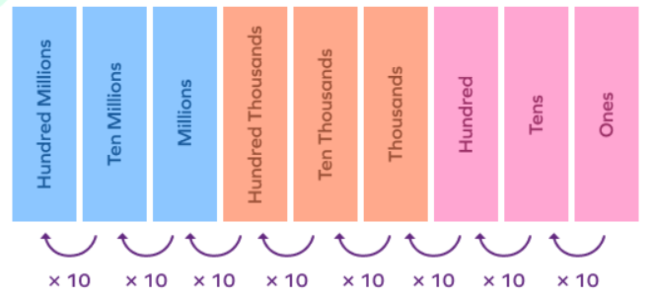

Let’s take the number 234 and find the place value of each digit using a place value chart.

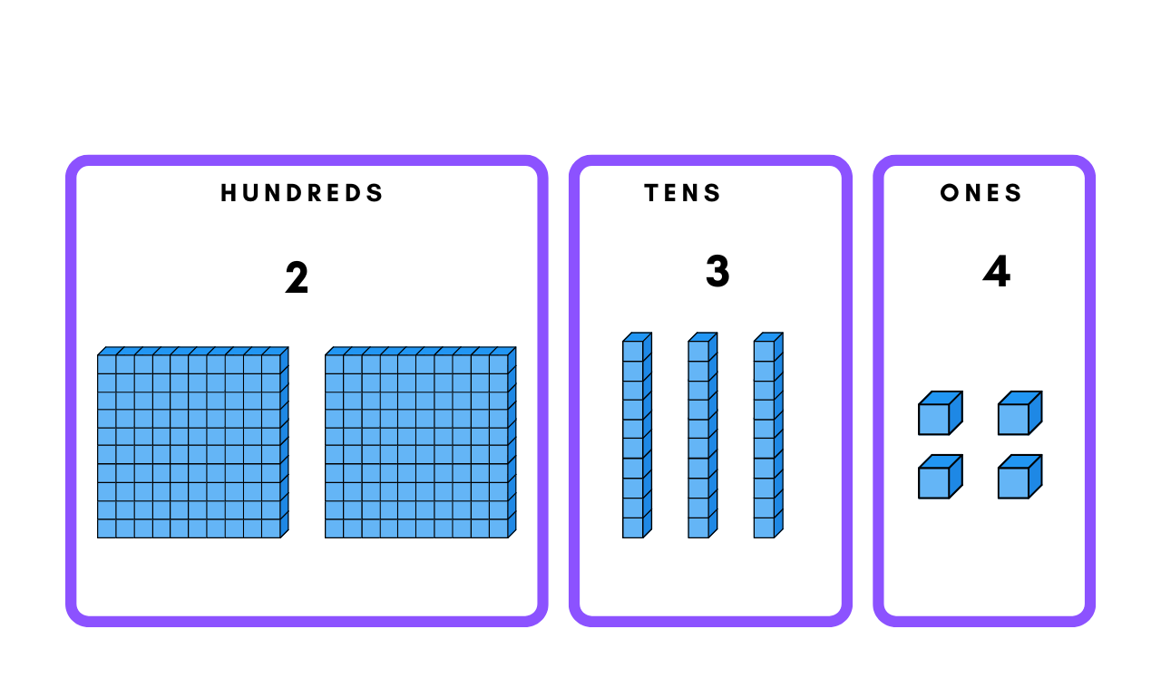

2 is in the hundreds place and has a value of 200

3 is in the tens place and has a value of 30

4 is in the ones and has a value of 4

The sum of each digit's place value gives the overall value of the number:

200 + 30 + 4 = 234

**Tally marks**

Tally marks are a simple and efficient way to count and record numbers. Imagine a classroom election where students are voting for their favorite fruit: apples, bananas, or oranges. The teacher can use tally marks to keep track of the votes.

As each student votes, the teacher adds a single vertical line next to the corresponding fruit for each vote. At every fifth vote for each fruit, the teacher draws a diagonal line across the previous 4 vertical lines to signify a group of 5.

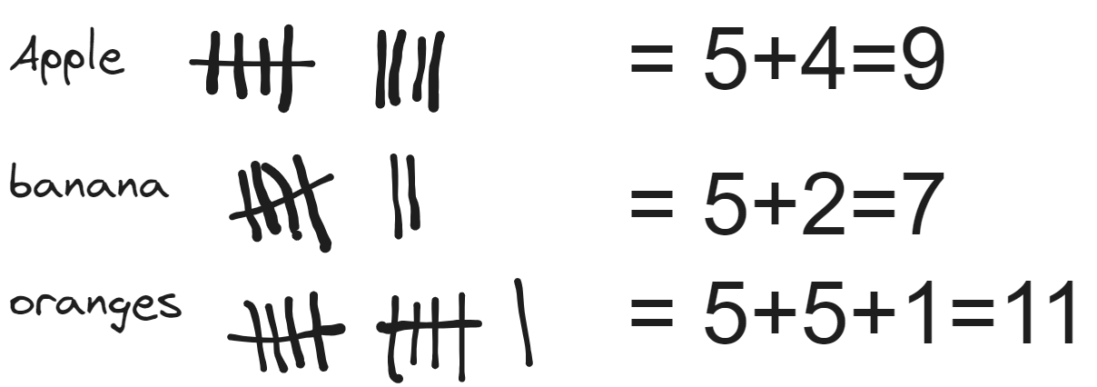

Tally marks are impractical to represent larger numbers, as it takes more time and space.

**Counters**

Counters are physical objects used to represent numbers. They can be anything from beads to blocks to coins. Using counters helps us visualize numbers and understand basic arithmetic operations. One of the oldest and most effective tools for using counters is the abacus.

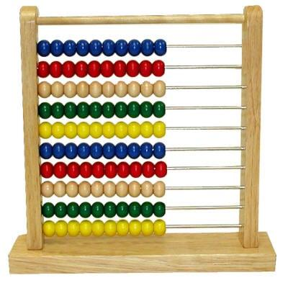

The abacus is a counting frame that has been used for centuries in various cultures to aid in calculations. An abacus consists of a rectangular frame with rods or wires, each rod represents a place value and has 10 beads in each rod.

Let’s assume the bottom rod represents the ones place and the rows above represent subsequently increasing place values. The representation below shows how to represent 2,534 using counters.

